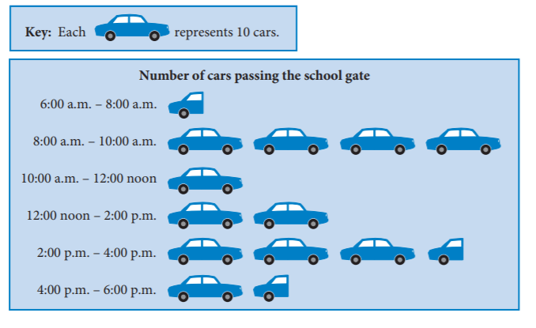
Question 1- PICTURE GRAPHS: These graphs use symbols to represent quantities. This picture graphs shows the number of cars passing Cengage High School at different times of the day
Interpreting Graphs Worksheet
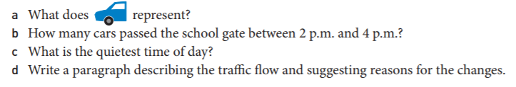
Question 2:
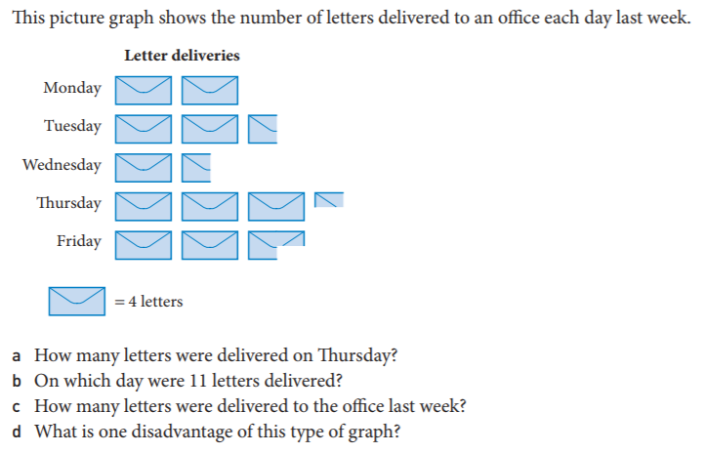
Question 3- COLUMN GRAPHS: These graphs are mostly used for data that is in categories. This column graph shows the populations of the eight Australian capital cities in June 2012.
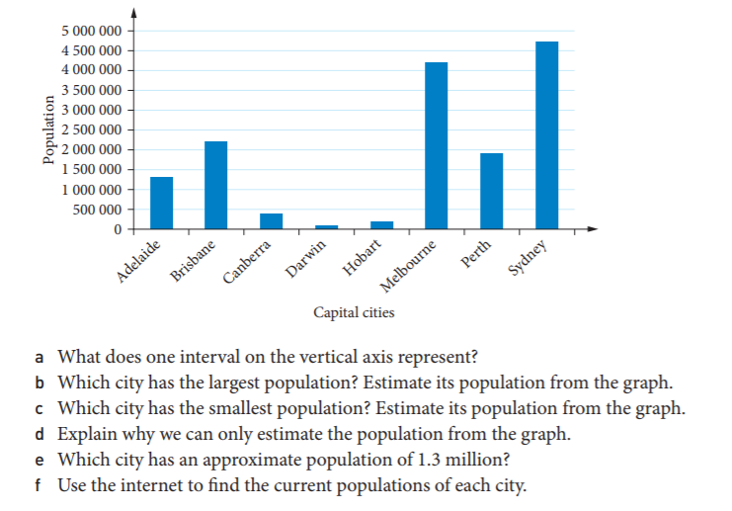
Question 4- COLUMN GRAPHS: A column graph on its side is called a BAR GRAPH
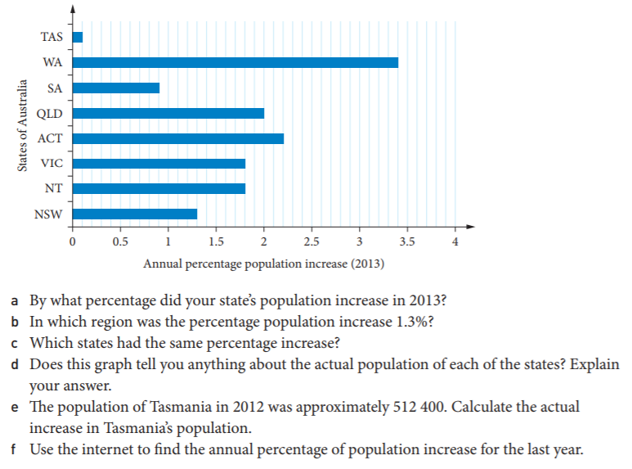
Question 5- CLUSTERED COLUMN GRAPHS: These graphs are used for categories we want to compare. This graphs shows the nutritional information for different foods
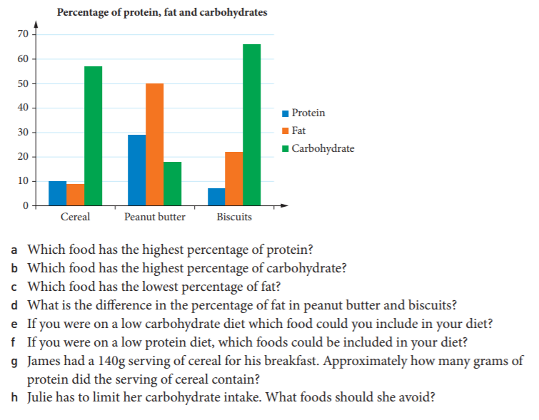

Question 6- LINE GRAPHS: These graphs are used to show the changes over time. This graph shows home loan rates at June in each of the given years
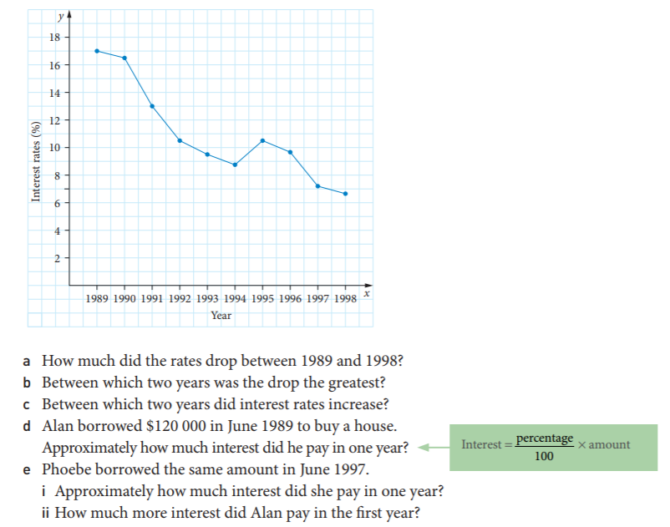
Question 7- CONVERSION GRAPHS: These graphs are used to convert from one unit to another. This graph can be used to convert Australian Dollars (AUD) to Euros (€)

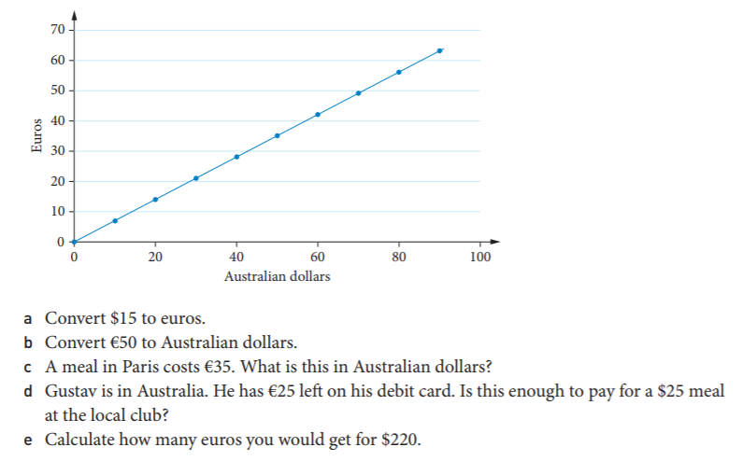

Question 8- STEP GRAPHS: These graphs are line graphs made up of “broken” horizontal intervals that look like steps. This graph shows the charges/cost of a dishwasher repairman called Graham.
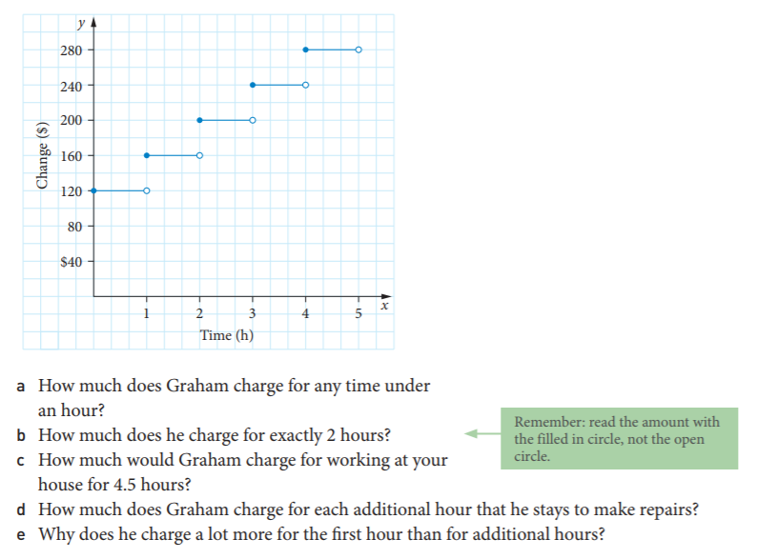
Question 9- PIE GRAPHS: This graph shows the results of a survey about people’s favourite TV sport.

